Coach Bob Derryberry
Boys Basketball
1963

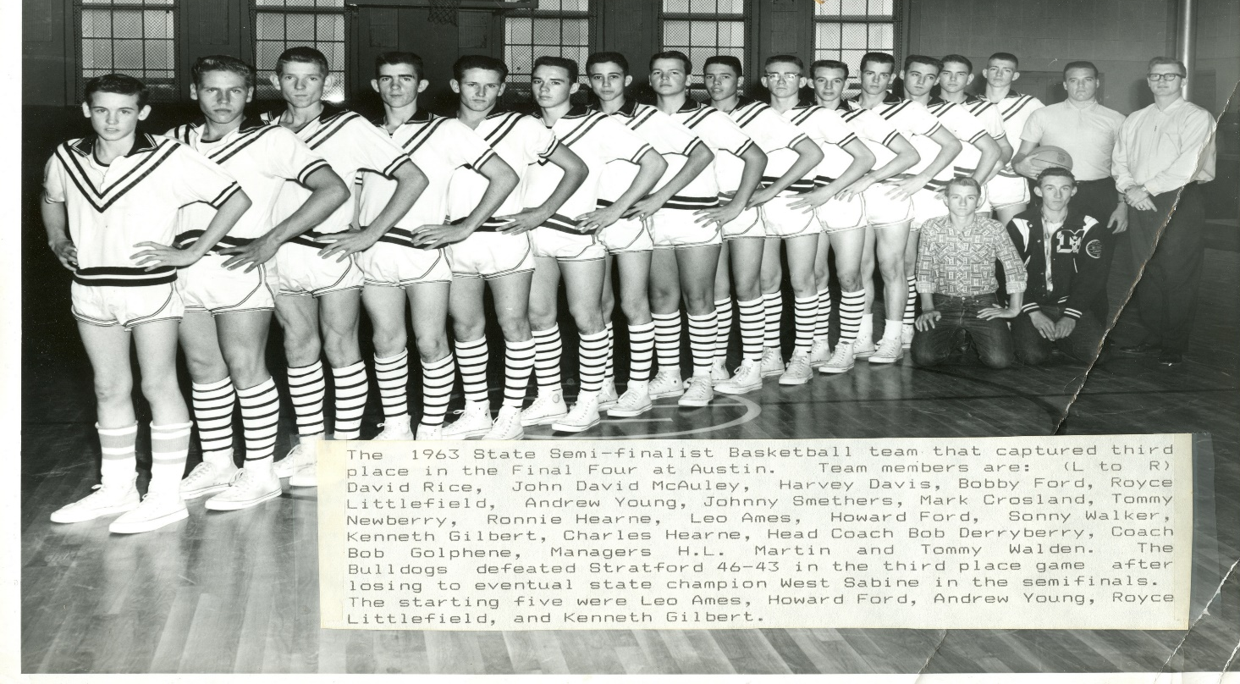

In 1963, the Millsap High School Boys Basketball Team reached a new level of competition as this team landed a berth at the State Tournament in Class 1A. This team will always be remembered as the first and only basketball thus far to achieve that accomplishment.
Throughout the season, Millsap (28-6), was led by Senior Leo Ames, averaging 17 points per game. Alongside Leo, were the fabulous four which included center Kenneth Gilbert, Andrew Young, Royce Littlefield and Howard Ford as well as reserve freshman standout Ronnie Hearne. When “old-timers” of the Millsap community speak of the past, this historic year is always one that is mentioned.
In game one of the state tournament, Millsap faced a tough West Sabine squad (32-3). In game one, the Bulldogs were led by Royce Littlefield who scored 15 points, followed by Andrew Young and Kenneth Gilbert each with 11. Rounding out the scoring in game one was Leo Ames with 7 and Howard Ford with 4 respectively. Millsap ended up falling to West Sabine who were the eventual State Champions. The Bulldogs defeated Stratford for a 3rd place finish at the State Tournament. In the final game, Leo Ames led all scorers for Millsap with 21 points, followed by Kenneth Gilbert with 9. The team ended the season with a 29-7 record.
As a result of this historic season, multiple Bulldogs were showered with various accolades for their performance on the hardwood including Leo Ames who received All-State and was a member of the North All-Stars Team.

